**Interaction Design Lab – Mini Project Week 05**

**Name: Nguyễn Duy Ân**

**Student ID: 2162372**

1. **Choose an app or a website that you think is badly designed**

In my opinion, The website with the worst design is the website of an environmental center, it's my friend's company website.

www.trungtamdoluong.com or www.trungtamdoluong.com.vn or [www.trungtamdoluong.vn](http://www.trungtamdoluong.vn)

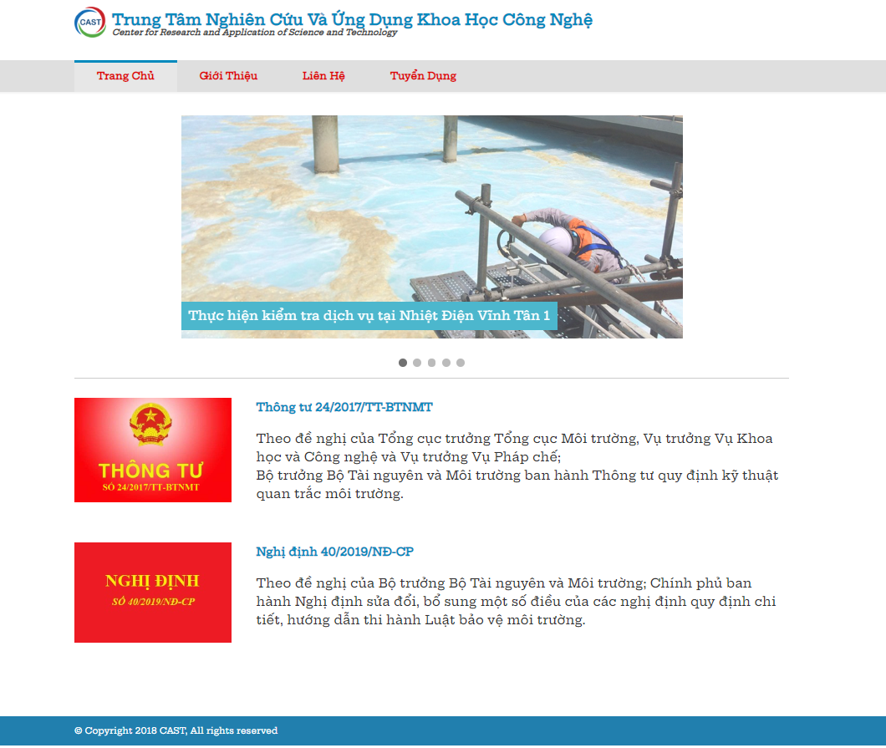

1. **Sketch the flow/sequence of screen/functionality**

* The first line is the logo and the center name (with english and vietnamese name).
* Second line is the main menu (home page, intro, contact, recruitment)

+ Home page: when we press, we have the screen (pic 1)

+ Introduction: when we press this, the website displays the company's profile, company competencies, what services the company has, and which companies have cooperated.

+ Contact: when we press this, the website will display Address/contact number/email of head office and lab office.

+ Recruitment: Absolutely no content at all.

* In the middle of the screen are 5 pictures in order. Each picture will be a typical project that the center has implemented.

Below the picture are some environmental laws enacted by the government.

1. **List things/items on the app/websites that are not right. Point out what you can do to correct the problems/issues**

- In the recruiting section, you should not leave it blank, making viewers feel uncomfortable. The font is not pretty, it looks messy. The function is simple, not yet to show all the information transmitted to the viewer. The website has no other languages. How to arrange the images and text frames is not reasonable

- Improve the site layout

add logo, because the website is environmental industry should have more environmental images.

Bigger fonts, viewers feel comfortable and not tangled

1. **Redesign that app/website with new flow/sequence of screen/functionality**

With the new website, I want the website to be designed with functions that can be connected to the faebook, skype.

With eye-catching website and green colour interface of the environment.